Sensitivity Analyses

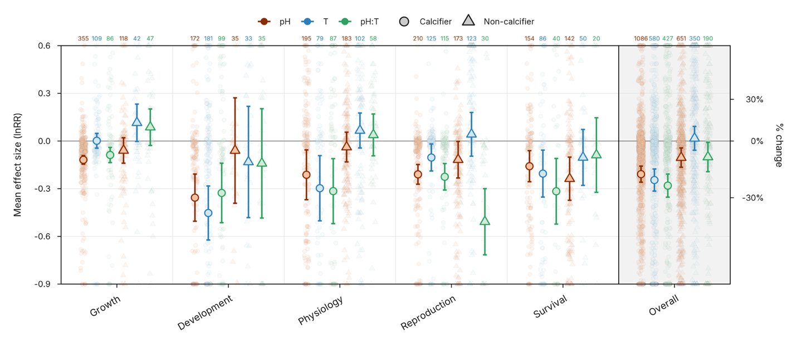
Supplementary Figure S1. Meta-analysis of impacts of climate change on zooplankton without removing the entries with ambiguous response variable direction, but treating the direction as positive.

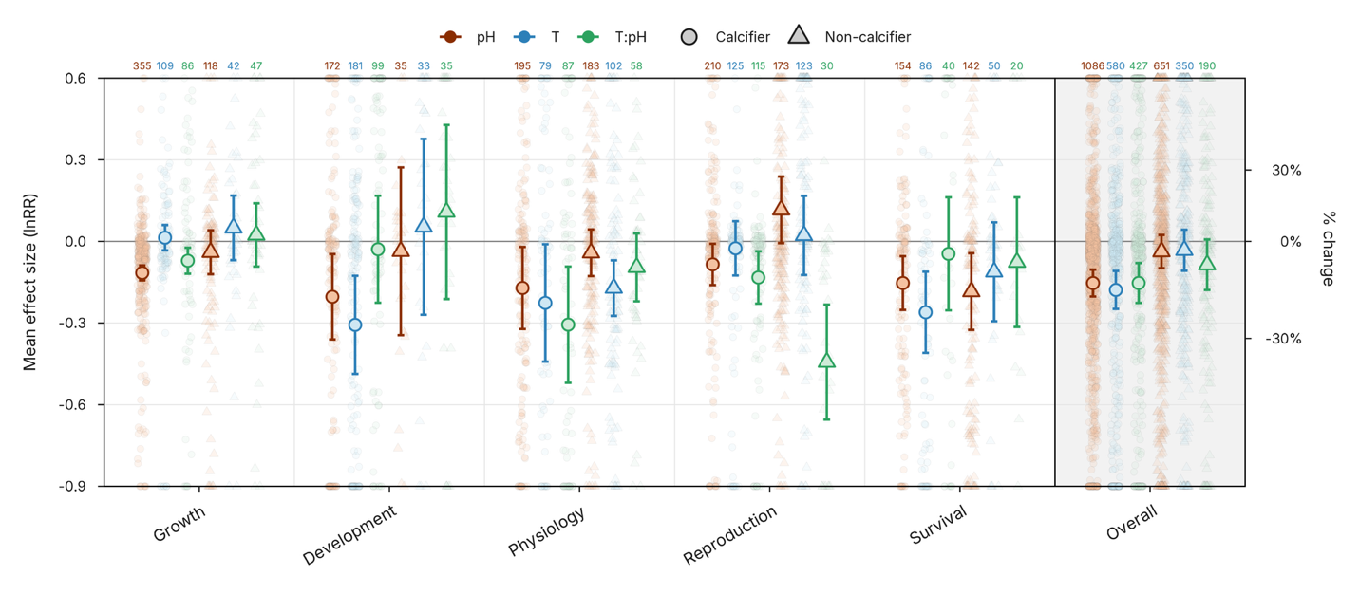
Supplementary Figure S2. Meta-analysis of impacts of climate change on zooplankton without removing the entries with ambiguous response variable direction, but treating the direction as negative.

